APPLECROSS SENIOR HIGH SCHOOL

HUMAN BIOLOGY YEAR 12

TEST 4

DO NOT MARK THIS TEST PAPER IN ANY WAY

SELECT THE BEST ALTERNATIVE IN EACH OF THE FOLLOWING QUESTIONS.
Mark your answer on the answer sheet provided.

- Which of the following statements BEST describes homeostasis?

  - Homeostasis maintains the core body temperature at a constant level.
  - Homeostatic mechanisms make the body relatively independent of external changes.
  - Thirst and hunger are homeostatic mechanisms.
  - Homeostasis ensures that cells always function at their optimum level.

- Which of the following is the correct sequence of events and structures that are involved in a steady state control system?

  - Stimulus → effector → receptor → modulator → response → feedback
  - stimulus → receptor → modulator → effector → response → feedback
  - stimulus → response → receptor → modulator → effector → feedback
  - feedback → stimulus → effector → modulator → receptor → response

- A feedback system:

  - reinforces a stimulus.
  - causes a response that opposes a stimulus.
  - initiates a response that changes (or reinforces) a stimulus.
  - involves the nervous system but not the endocrine system.

- Receptors are:

  - nerve centres in the spinal cord.
  - centres in the brain that receive nerve impulses.
  - specialised nervous tissue sensitive to changes in our surroundings.
  - nerves that conduct impulses within the central nervous system.

Question 5 refers to the diagram below of a nerve cell (neuron).

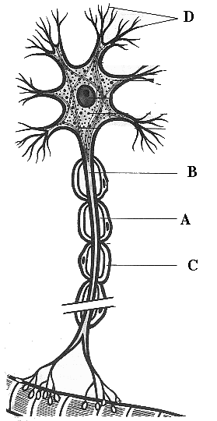

5. In the diagram

- A is the neurilemma, B is the axon, C is the myelin sheath, D is a dendrite.
- A is the neurilemma, B is the myelin sheath, C is a dendrite, D is the axon.
- A is the myelin sheath, B is the axon, C is the neurilemma, D is a dendrite.
- A is the myelin sheath, B is the dendrite, C is the neurilemma, D is an axon.

6. Myelination of a nerve fibre

- causes a slower conduction of nerve impulses along the fibre.
- prevents the nerve impulses from jumping along the fibre.
- slows the fibre’s return to normal following conduction of an impulse.
- speeds up the passage of nerve impulses along the fibre.

7. The point where a nervous impulse is transferred from a neuron to a muscle fibre is called the

- synapse.
- neurotransmitter.
- motor end plate.
- interneuron.

8. In a neuron, the impulse is conducted through the dendrite to the

- myelin sheath.
- axon.
- associated sensory neuron.
- cell body.

Questions 9, and 10 refer to the diagram below showing some components of a reflex arc.

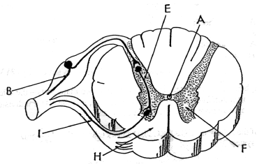

9. Which of the following is CORRECT?

- H is gray matter which contains nerve cell bodies.
F is white matter which contains myelinated fibres.

- H is gray matter which contains myelinated fibres.
F is white matter which contains nerve cell bodies.

- H is white matter which contains myelinated fibres.
F is gray matter which contains nerve cell bodies.

- H is white matter which contains nerve cell bodies.
F is gray matter which contains myelinated fibres.

10. The CORRECT sequence of structures involved in transmitting impulses as part of a simple reflex arc is

- B (sensory neuron), E (interneuron), I (motor neuron).
- B (motor neuron), E (interneuron), I (sensory neuron).
- I (sensory neuron), E (interneuron), B (motor neuron).
- I (motor neuron), E (interneuron), B (sensory neuron).

11. The fluid in the semi-circular canals of the inner ear
  - moves the tectorial membrane against hair cells that send impulses to the brain to be interpreted as equilibrium
  - bends hair cells that send impulses to the brain to be interpreted as equilibrium
  - moves the tectorial membrane against hair cells that send impulses to the brain to be interpreted as sound
  - bends hair cells that send impulses to the brain to be interpreted as sound

12. Which of the following is an essential component of all reflex arcs?

- A myelin sheath
- A synapse
- A Schwann cell
- The brain

13. The organs of balance are

- malleus, cochlea and utricles
- semi circular canals, utricles and saccules
- cochlea, semi circular canals and saccules
- saccules, malleus and semi circular canals

14. During accommodation for near vision the

- aqueous humour causes the lens to bulge
- lens flattens
- lens relaxes
- lens remains the same shape

15. The small granules of calcium carbonate found within the middle ear that assist in maintaining balance are called

- saccules
- otoliths
- perilymph
- ampullae

16. The greatest amount of refraction of light rays entering the eye occurs at the

- cornea.
- aqueous humour.
- lens.
- vitreous humour.

17. Which of the following increases in importance for vision if the level of illumination decreases?

- Cones
- Rods
- Cones and rods equally
- Fovea

Questions 18 and 19 refer to the diagram below of the human eye.

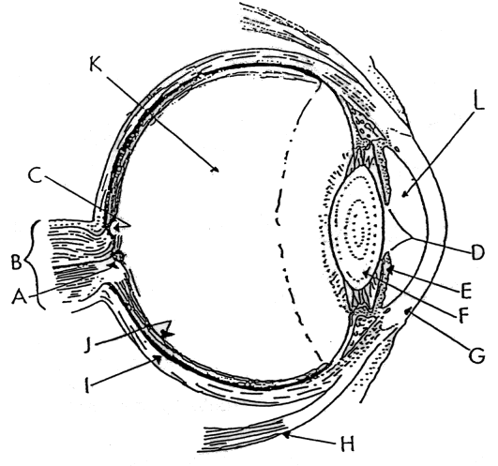

18. Which of the following is CORRECT?

- K contains aqueous humour.
- Structure G is involved in accommodation.
- Visual discrimination is highest at structure A.
- Structure E is involved in controlling the amount of light entering the eye.

19. Which of the following is INCORRRECT?

- Structure J is involved in generating nerve impulses.
- Structure I prevents internal reflection of light.
- Structure B consists of nerve fibres.
- Structure C consists mainly of rods.

20. Which structure controls the amount of light entering the eye?

- The pupil
- The lens
- The iris
- The ciliary muscle

Question 21 refers to the diagram of the eye below.

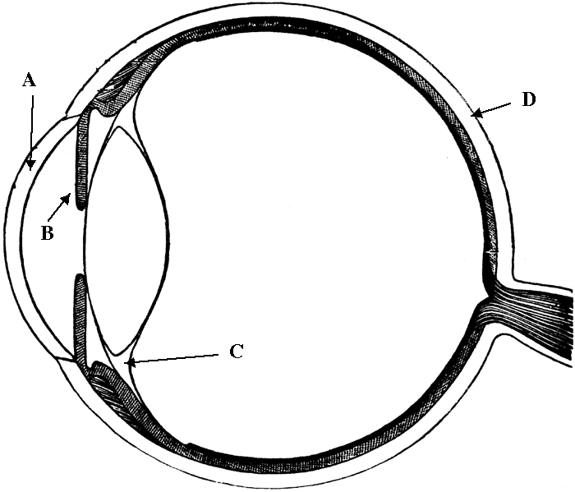

21. On the diagram of the eye

- A is the cornea, B is the suspensory ligament, C is the iris, D is the sclera.
- A is the sclera, B is the suspensory ligament, C is the iris, D is the cornea.
- A is the cornea, B is the iris, C is the suspensory ligament, D is the sclera.
- A is the cornea, B is the iris, C is the suspensory ligament, D is the retina.

22. Vibration of the tympanic membrane of the ear

- is important in maintaining balance.
- occurs due to the action of sound waves.
- provides information to the semicircular canals.
- is suppressed by the auditory ossicles.

23. Which of the following separate the middle ear from the inner ear?

- The oval window and the round window.
- the oval window and the tympanic membrane.
- The oval window, the round window and the tympanic membrane.
- The oval window, the round window and the Organ of Corti.

Question 24 refers to the diagrams W, X, Y and Z below showing light rays entering human eyes.

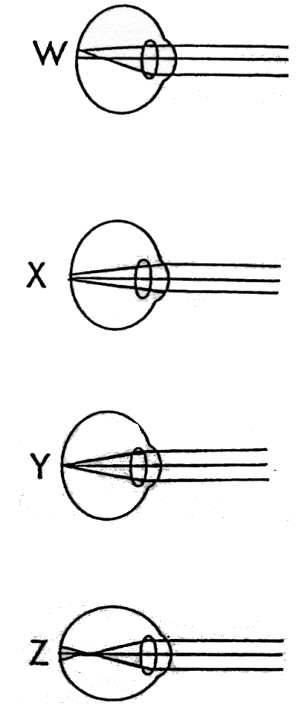

24. Which of the following is CORRECT?

a) W is myopia (short-sightedness).
X is hypermetropia (long-sightedness).
Y is astigmatism.
Z is normal.

- W is astigmatism.
X is myopia (short-sightedness)
Y is normal.
Z is hypermetropia (long-sightedness).

- W is astigmatism.
X is hypermetropia (long-sightedness).
Y is normal.
Z is myopia (short-sightedness).

- W is myopia (short-sightedness).
X is astigmatism.
Y is hypermetropia (long-sightedness).
Z is normal.

25. Hypermetropia (long-sightedness) describes a condition where

- distant objects are seen clearly but close objects are difficult to focus.
- close objects are seen clearly but distant objects appear fuzzy.
- the curvature of the cornea or lens is not uniform.
- the retina contains an adequate number of rods but no cones.
26. Spectacles with concave lenses help to correct

- myopia (short-sightedness).
- hypermetropia (long-sightedness).
- astigmatism.
- hypermetropia (long-sightedness) and astigmatism.

Questions 27, 28 and 29 refer to the diagram below:

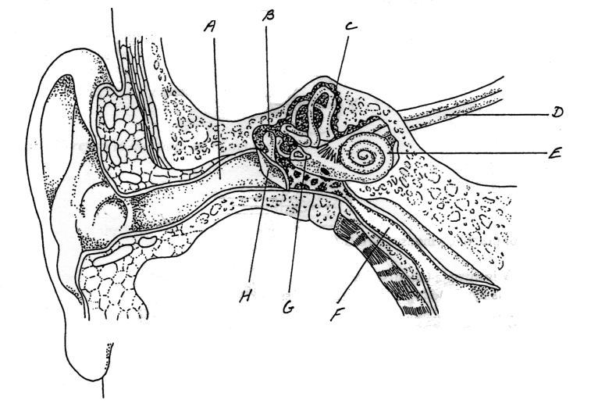

27. The receptors for sound are located in:

- B.
- C.
- E.
- G.

28. The part of the ear that detects movement of the head is:

- B.
- C.
- D.
- F.

29. A structure that allows air pressure in the middle ear to become the same as the pressure on the outer ear is:

- A.
- D.
- F.
- H.

30. This question relates to the list below of seven events which occur in a human inner ear.

1. Movement of the hair cells of the Organ of Corti.
2. Movement of the round window.
3. Pressure waves in the endolymph of the cochlea.
4. Movement of the ossicles.
5. Pressure waves in the perilymph of the bony tubes.
6. Pressure relieved by the Eustachian tube.
7. Movement of the oval window.

In the human inner ear a correct sequence of events listed above that leads to hearing is

- 7, 5, 3, 6.
- 4, 2, 5, 1.
- 4, 7, 5, 3.
- 7, 5, 3, 1.

END OF PAPER

